**Project Design Phase**

**Solution Architecture**

| **Date** | 22/06/2025 |
| --- | --- |
| **Team ID** | **LTVIP2025TMID48146** |
| **Project Name** | iRevolution: A Data-driven Exploration of Apple's iPhone Impact in India using Tableau |
| **Maximum Marks** | 4 Marks |

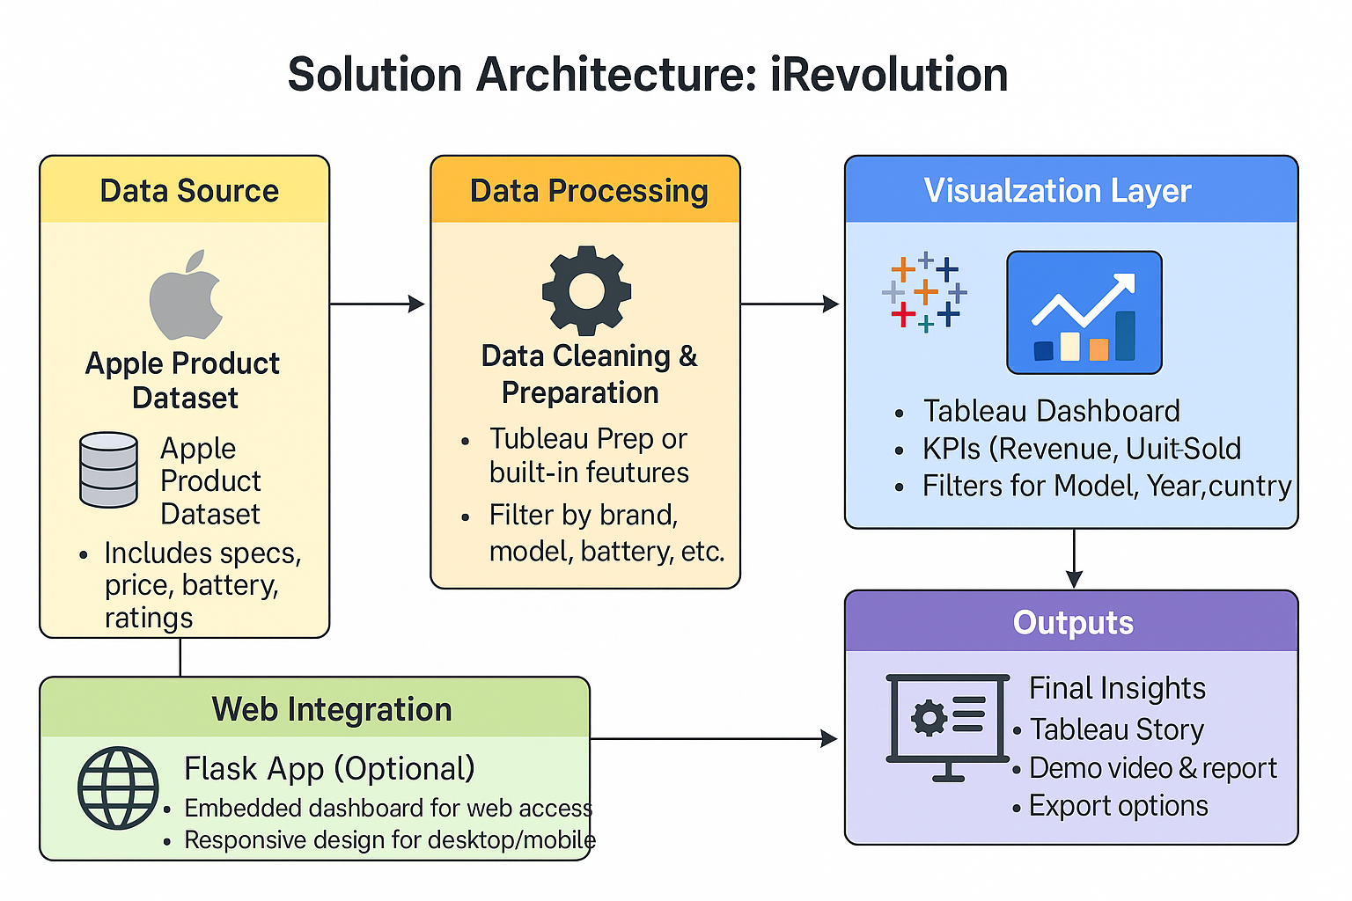

This architecture visually outlines the key stages of the iRevolution project — from raw data to final insights:

1. Data Source:  
   * Apple product dataset from Flipkart/Kaggle
   * Includes specs like price, battery, storage, and ratings
2. Data Processing:  
   * Data cleaned and filtered using Tableau Prep or built-in tools
   * Filters applied: brand, model, battery type, etc.
3. Visualization Layer:  
   * Built in Tableau
   * Includes dashboards with KPIs like revenue and units sold
   * Filters: Year, Model, Country
4. Web Integration (Optional):  
   * Flask app to embed dashboard
   * Responsive design for mobile/desktop access
5. Outputs:  
   * Tableau story, demo video, exportable reports
   * Final deliverables for presentation or user access